LAB 01: - Uploading data on Thing speak open source Cloud Platform

**Objective:** - Learn about popular Microcontroller NodeMcu [Esp8266] and upload data on open source cloud platform and visualize the data in form of graph and charts and download data later for analysis

**Components: -**

1. NodeMcu [Esp8266]
2. Breadboard
3. DHT-11
4. Jumper Wires
5. Ultrasonic Sensor

**Software**: - Arduino Ide

**Application**: - Water tank monitoring system , intrusion detection system, smart stick for blind, weather station logger , Wine bottle Temperature Monitoring Device

**Description of sensor**

NodeMcu[Esp8266]

**[1] Node MCU** is an open source [IoT](https://en.wikipedia.org/wiki/Internet_of_Things) platform It includes [firmware](https://en.wikipedia.org/wiki/Firmware) which runs on the [ESP8266](https://en.wikipedia.org/wiki/ESP8266) [Wi-Fi](https://en.wikipedia.org/wiki/Wi-Fi) [SoC](https://en.wikipedia.org/wiki/System_on_a_chip) from [Espressif Systems](https://en.wikipedia.org/w/index.php?title=Espressif_Systems&action=edit&redlink=1" \o "Espressif Systems (page does not exist)), and hardware which is based on the ESP-12 module. The term "NodeMCU" by default refers to the firmware rather than the development kits. The firmware uses the [Lua](https://en.wikipedia.org/wiki/Lua_(programming_language)) scripting language. It is based on the eLua project and built on the Espressif Non-OS SDK for ESP8266. It uses many open source projects, such as lua-cjsonx

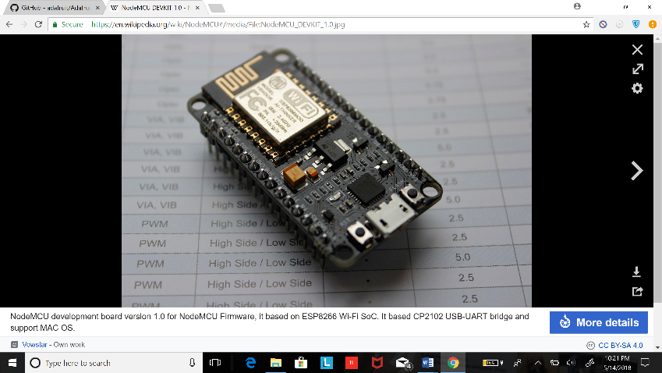

[2] Dht-11 is low cost temperature & humidity sensors. These sensors are very basic and slow but are great for hobbyists who want to do some basic data logging. The DHT sensors are made of two parts, a capacitive humidity sensor and a thermistor. There is also a very basic chip inside that does some analog to digital conversion and spits out a digital signal with the temperature and humidity. The digital signal is fairly easy to read using any microcontroller

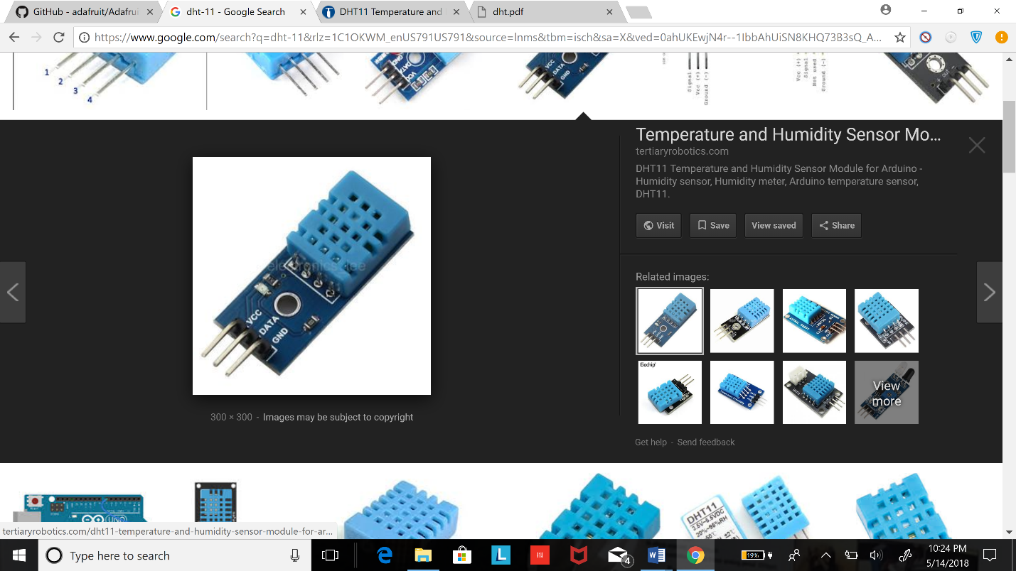

**[3]** Ultrasonic ranging module HC - SR04 provides 2cm - 400cm non-contact measurement function, the ranging accuracy can reach to 3mm. Application are Tank Level, Intrusion detection , Distance Measurement

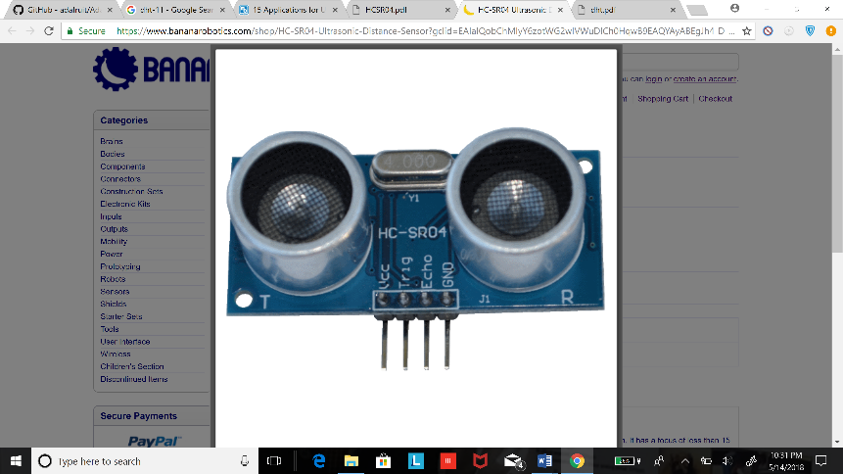

**Follow The Steps: -**

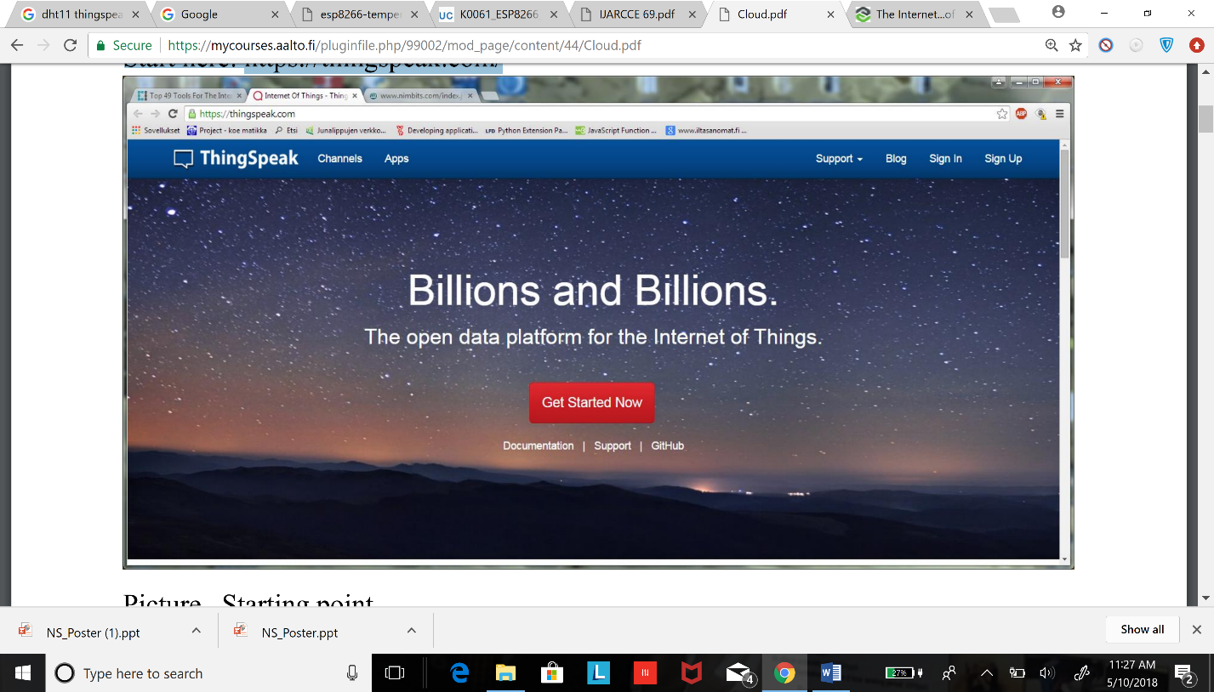**Step 1: - Configure cloud platform**

* **Create Account** [**https://thingspeak.com/**](https://thingspeak.com/)
* 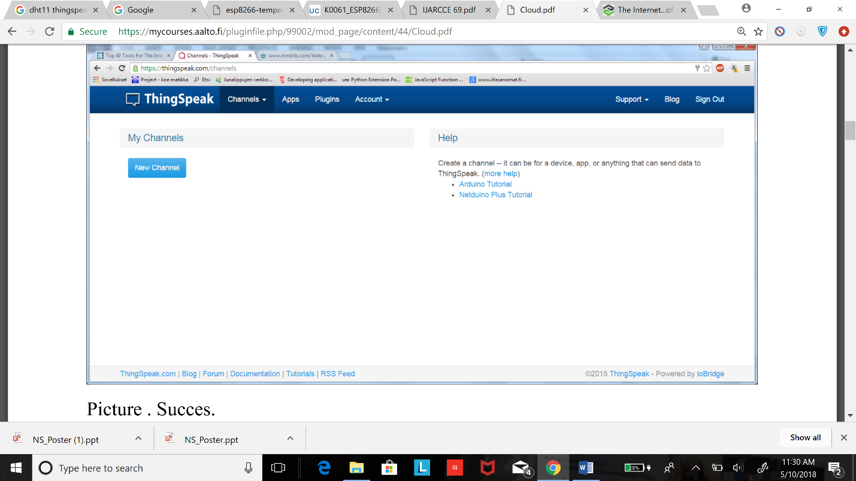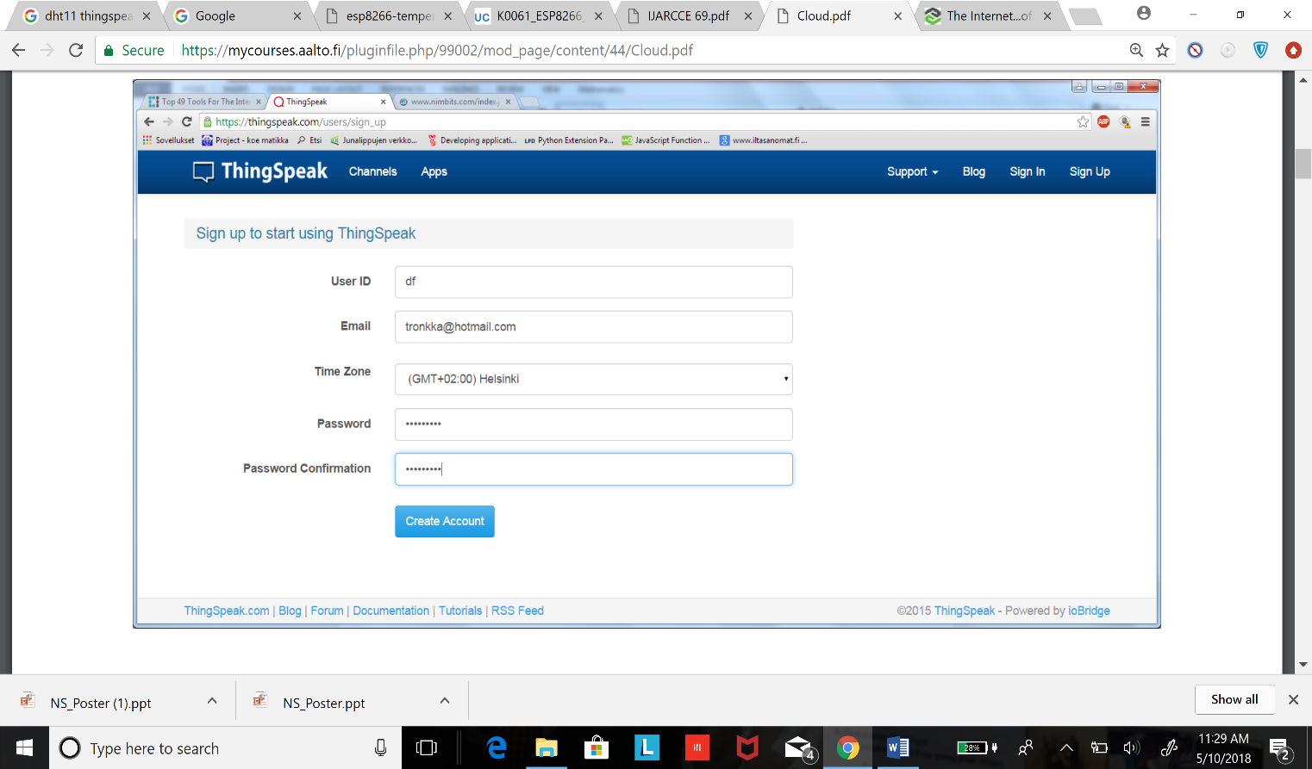**Enter Your credentials**
* 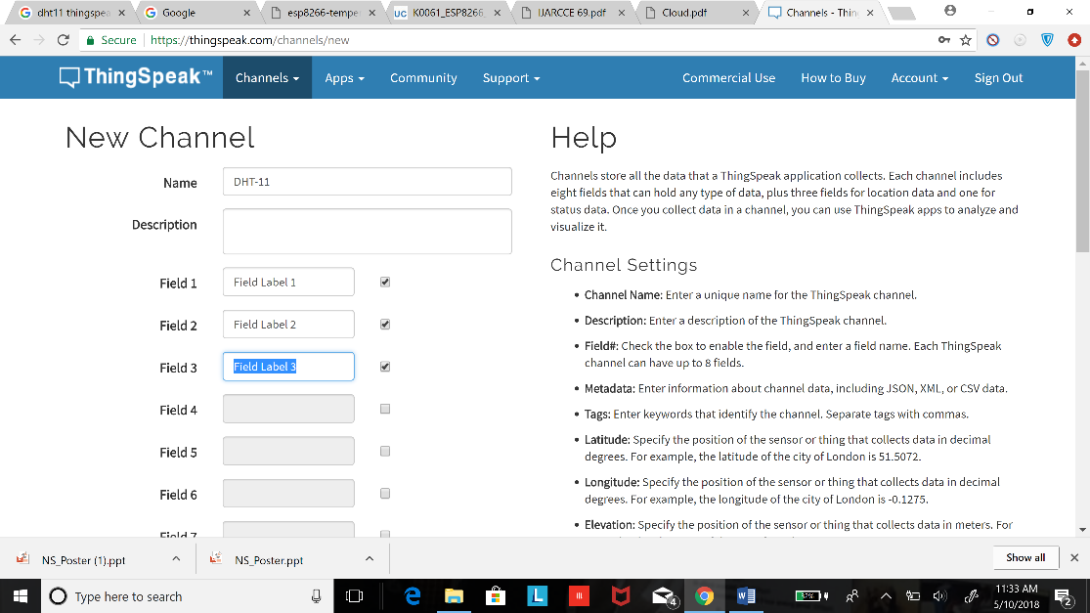After Filling Details hit create Account
* Picture of Success if you see this screen Good going Go-ahead and create a new channel

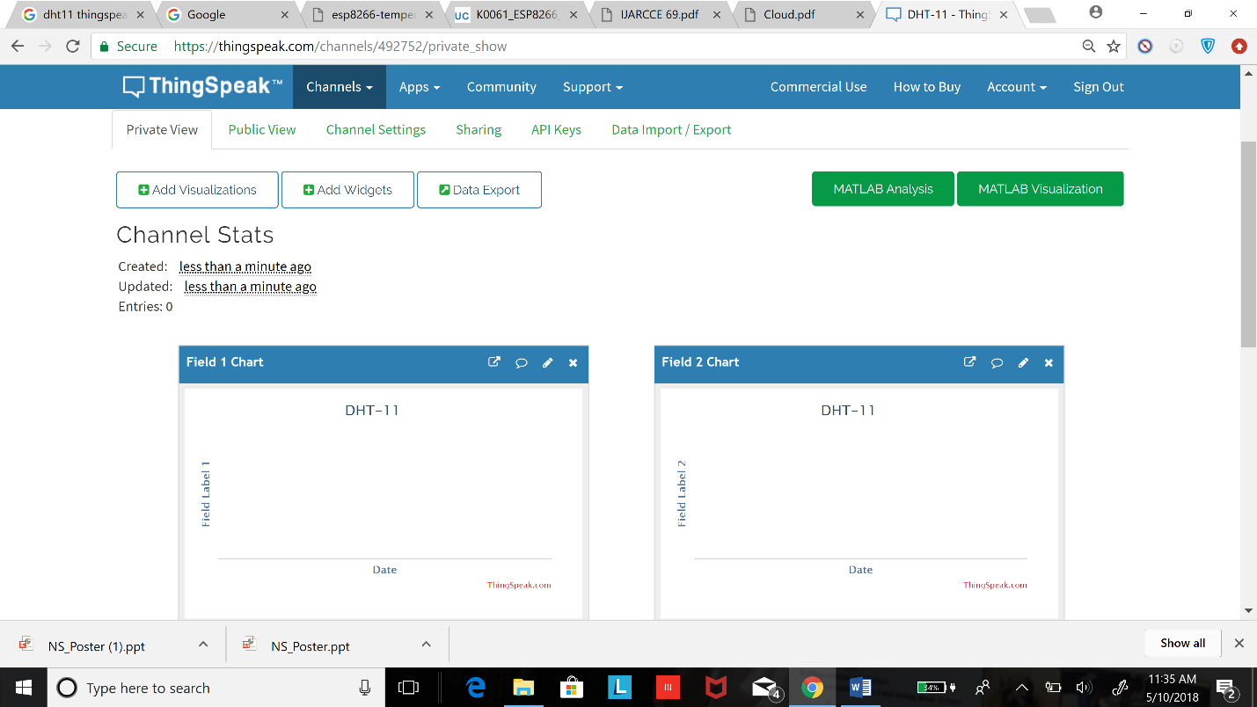

* If you see this screen You have successfully created and configured your cloud platform

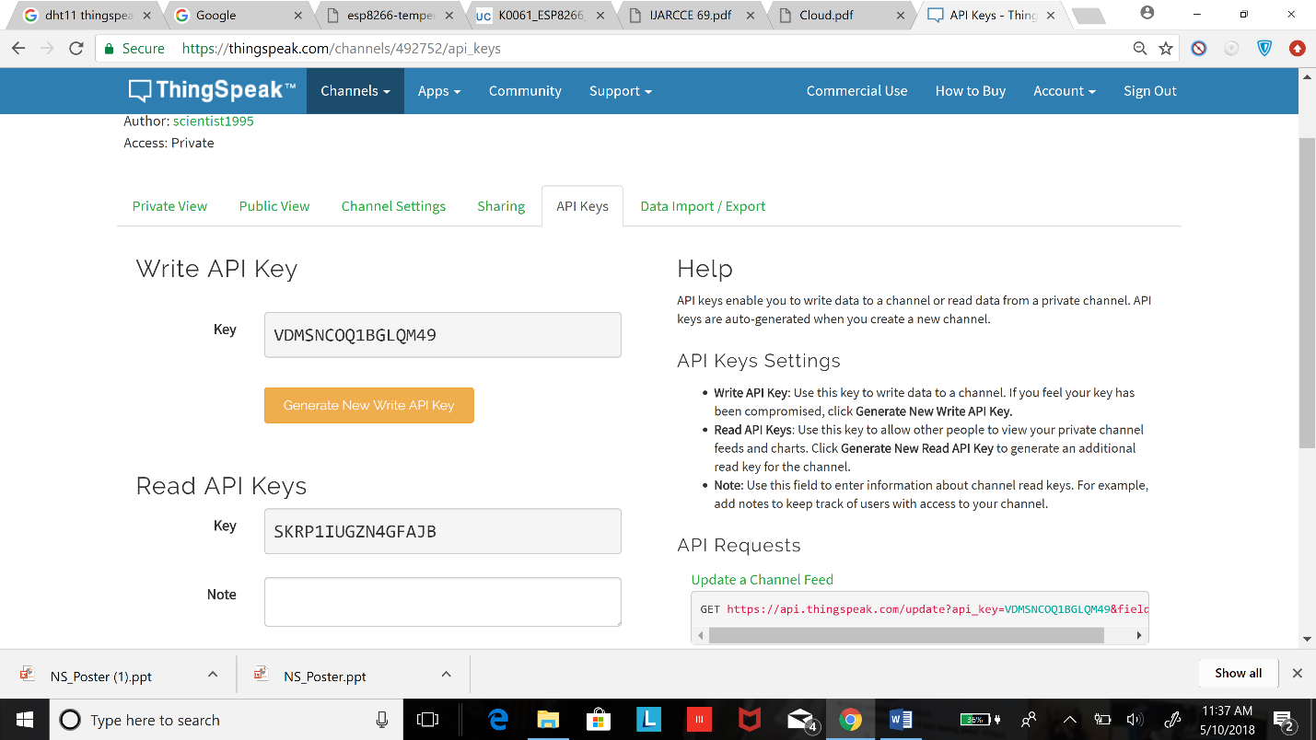

* Copy the Read and Write API keys do not share with anyone this secret Key

Step 2: - Configure Software on you Laptop

* Arduino Ide:- The Arduino IDE The Arduino Integrated Development Environment (IDE) is the tool you will use to program the ESP8266. IDEs are more than just editors; they help you with various tasks during the development process
* To install the Arduino IDE, go to <https://www.arduino.cc/en/Main/Software>
* Installing Esp8266 Tool Chain
* Install the ESP8266 tool chain A tool chain is the set of tools that lets you compile and create binaries for a certain platform. Since we want to create binaries for the ESP8266 we need a different tool chain than the one that comes with the plain vanilla Arduino IDE. The Arduino IDE has a wonderful feature, Board Manager, to save you the hassle of downloading many different files and copying them into obscure locations. It lets you install support for many different chips and boards with just a few clicks. But first of all we have to tell the Arduino IDE where it should look for board definitions:
* Open the Arduino IDE
* Go to your preferences/settings and in the text box Additional Board Manager URLs enter this URL:
* <http://arduino.esp8266.com/stable/package_esp8266com_index.json>
* Now go to Tools > Board: … > Boards Manager…, search for the ESP8266 board and click Install.
* Get a coffee and wait until it finishes

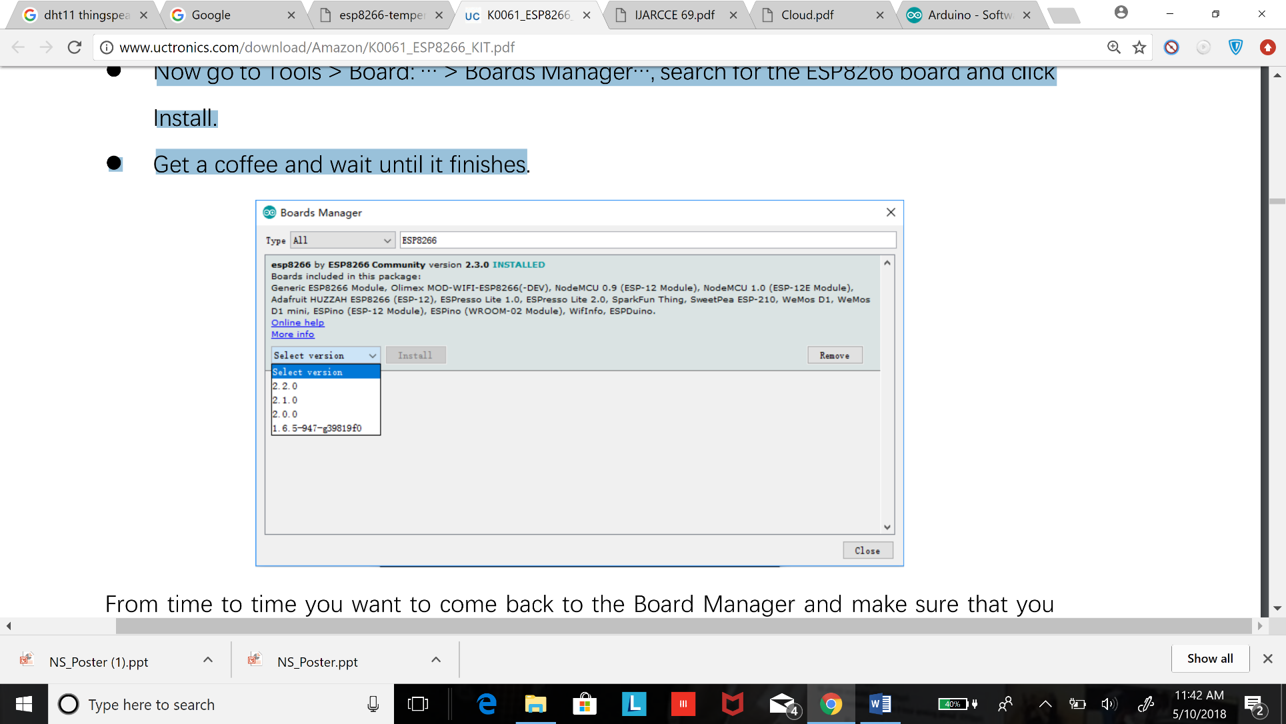

* From time to time you should come to board Manager and maker sure you have latest version of Board manager package Installed
* **Selecting the Correct Board**
* Now your Arduino IDE knows about ESP8266 boards in general. But not all the ESP8266 boards are the same; there are subtle but important differences in available Flash Memory and how they can be programmed. The selection of the correct board also defines the names of the GPIO pins: the designers of the NodeMCU decided to introduce a completely new naming scheme for the pins. Instead of calling them GPIO1, GPIO2 etc they decided to give them different numbers by using a “D”- prefix. So D0 is GPIO16, D1 is GPIO5 and so on. By selecting a NodeMCU board you automatically have the D naming scheme available, and this helps a lot since these names are also printed on the module board.
* So, let’s pick the correct board. If you bought the original Squix Starter Kit you will have to choose a NodeMCU 1.0: Go to Tools > Board: * > NodeMCU 1.0 (ESP-12E Module) There is a plentitude of modules available. Please make sure that you have the correct board selected before you continue.

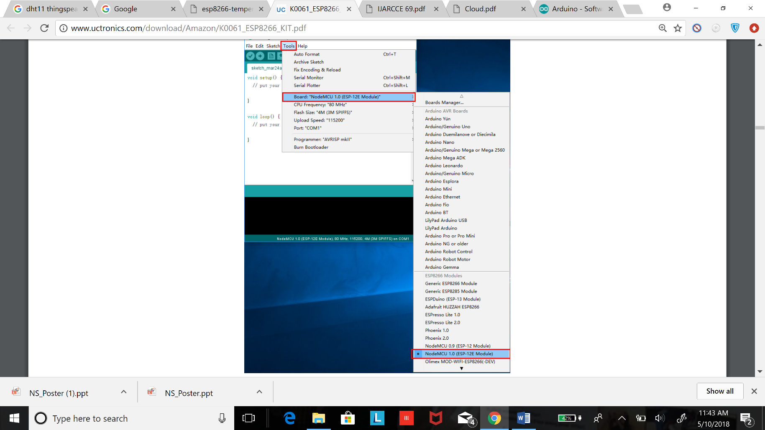

* Setting up correct Port
* In an earlier step, you already installed the drivers for this converter. If everything went well and the board is plugged into your computer you should now be able to select the serial connection. It should show up in the Menu under Tools > Port. On my Mac the device is called /dev/cu.SLAB_- USBtoUART. On a PC it should be listed as a COM port labelled COM# (where # is some number).
* If you cannot see a device that looks like the NodeMCU, try to unplug the ESP module and re-plug it after a few seconds. Also try a different USB socket. If that doesn’t help consider restarting your computer… Make sure that you installed the driver as mentioned in the chapter about drivers.
* Serial interface: At the hardware level the ESP8266 is programmed through a serial interface. In short this is a very common communication interface which normally requires three lines: transmit (TX), receive (RX) and ground (GND). Both devices involved in the communication need to agree on the rate the characters are sent over the wire. This rate is usually measured in BAUD. 10 BAUD is equal to 1 character per second. Your average PC or Mac doesn’t have such a serial interface, so how can we program the ESP8266? This is done through a Serialto-USB converter. Some ESPs already come with a built-in converter; others need an external one for programming.

Step 3: -

Testing ESP8266 Board

* Thanks for bearing with the complicated preparation until getting to the really cool part. We are going to run our first program on the NodeMCU! In the Menu of the Arduino IDE go to File > Examples > ESP8266Wifi and select WiFiScan. A new window will open up. This window is your current project and is also called a “Sketch”. To compile and transfer the binary to the ESP8266 click on the green circle that contains an arrow on the very top of the window. If everything went well this will compile the sketch andupload the binary to the ESP. It might look something like this

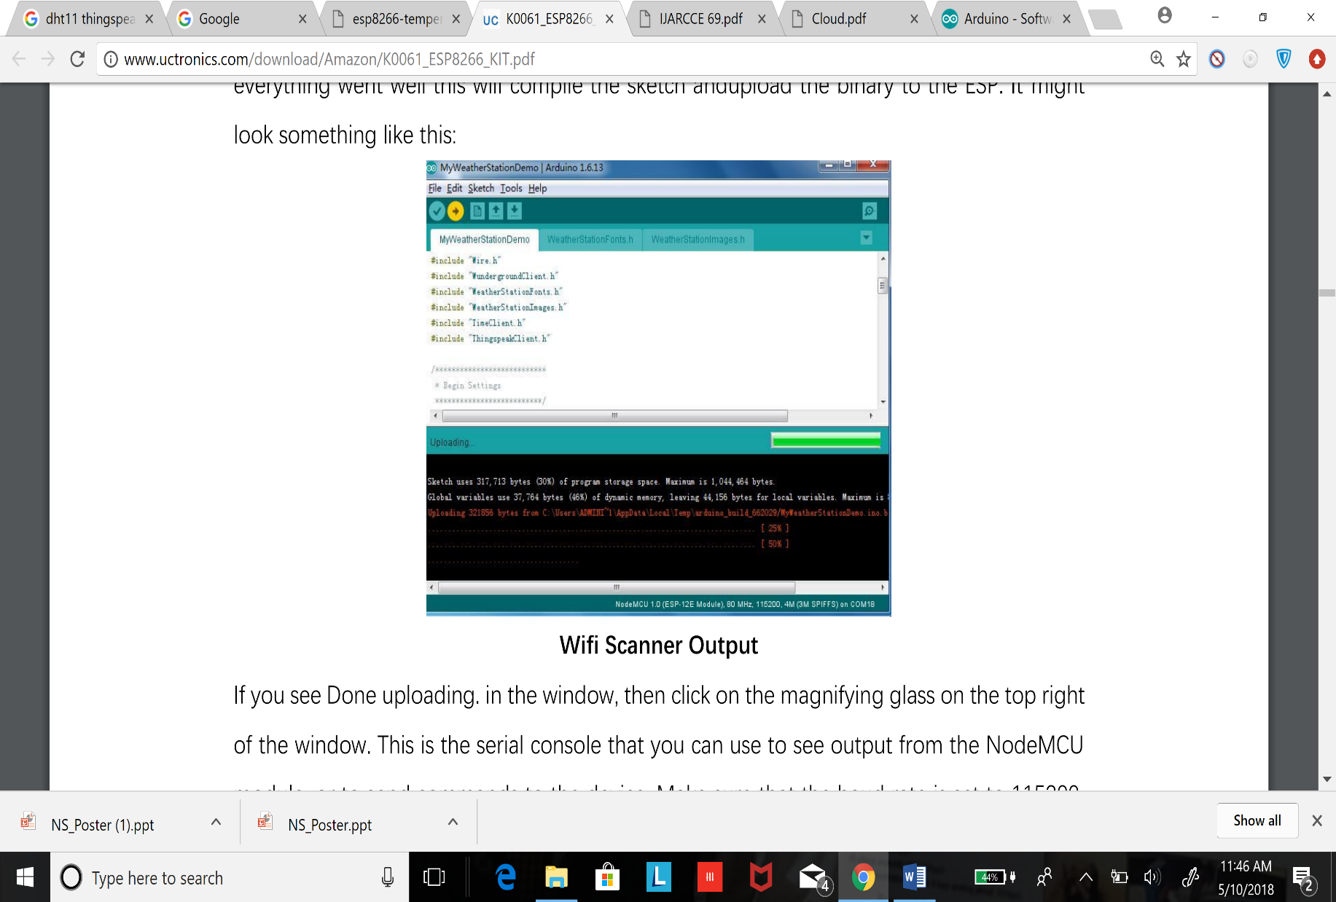

* If you see Done uploading. in the window, then click on the magnifying glass on the top right of the window. This is the serial console that you can use to see output from the NodeMCU module, or to send commands to the device. Make sure that the baud rate is set to 115200. This rate is also set in the example code, and if you have a different setting the ESP will talk with a different speed than your PC listens. You can set the baud rate on the bottom left of the serial monitor. My output looks like this

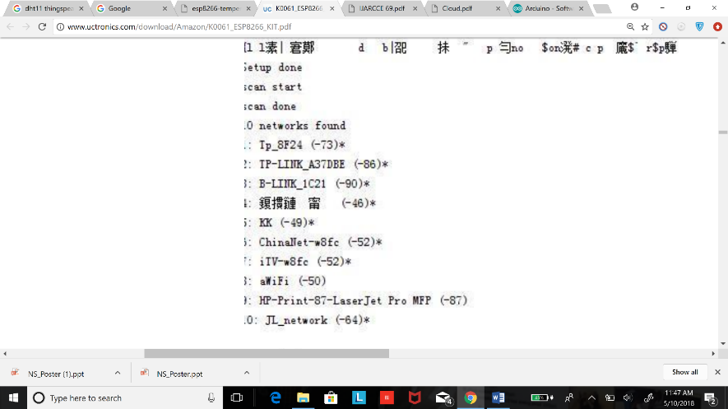

* **If you see something similar: congratulations! You have just set all the preconditions to run the code**

**Step 4: -**

* **Wire up hardware**

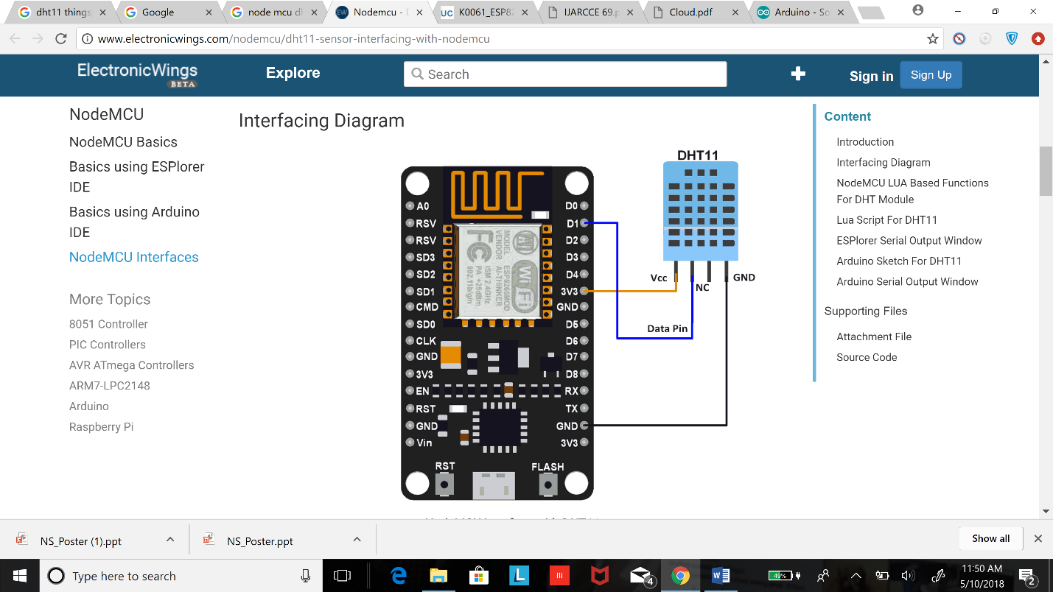

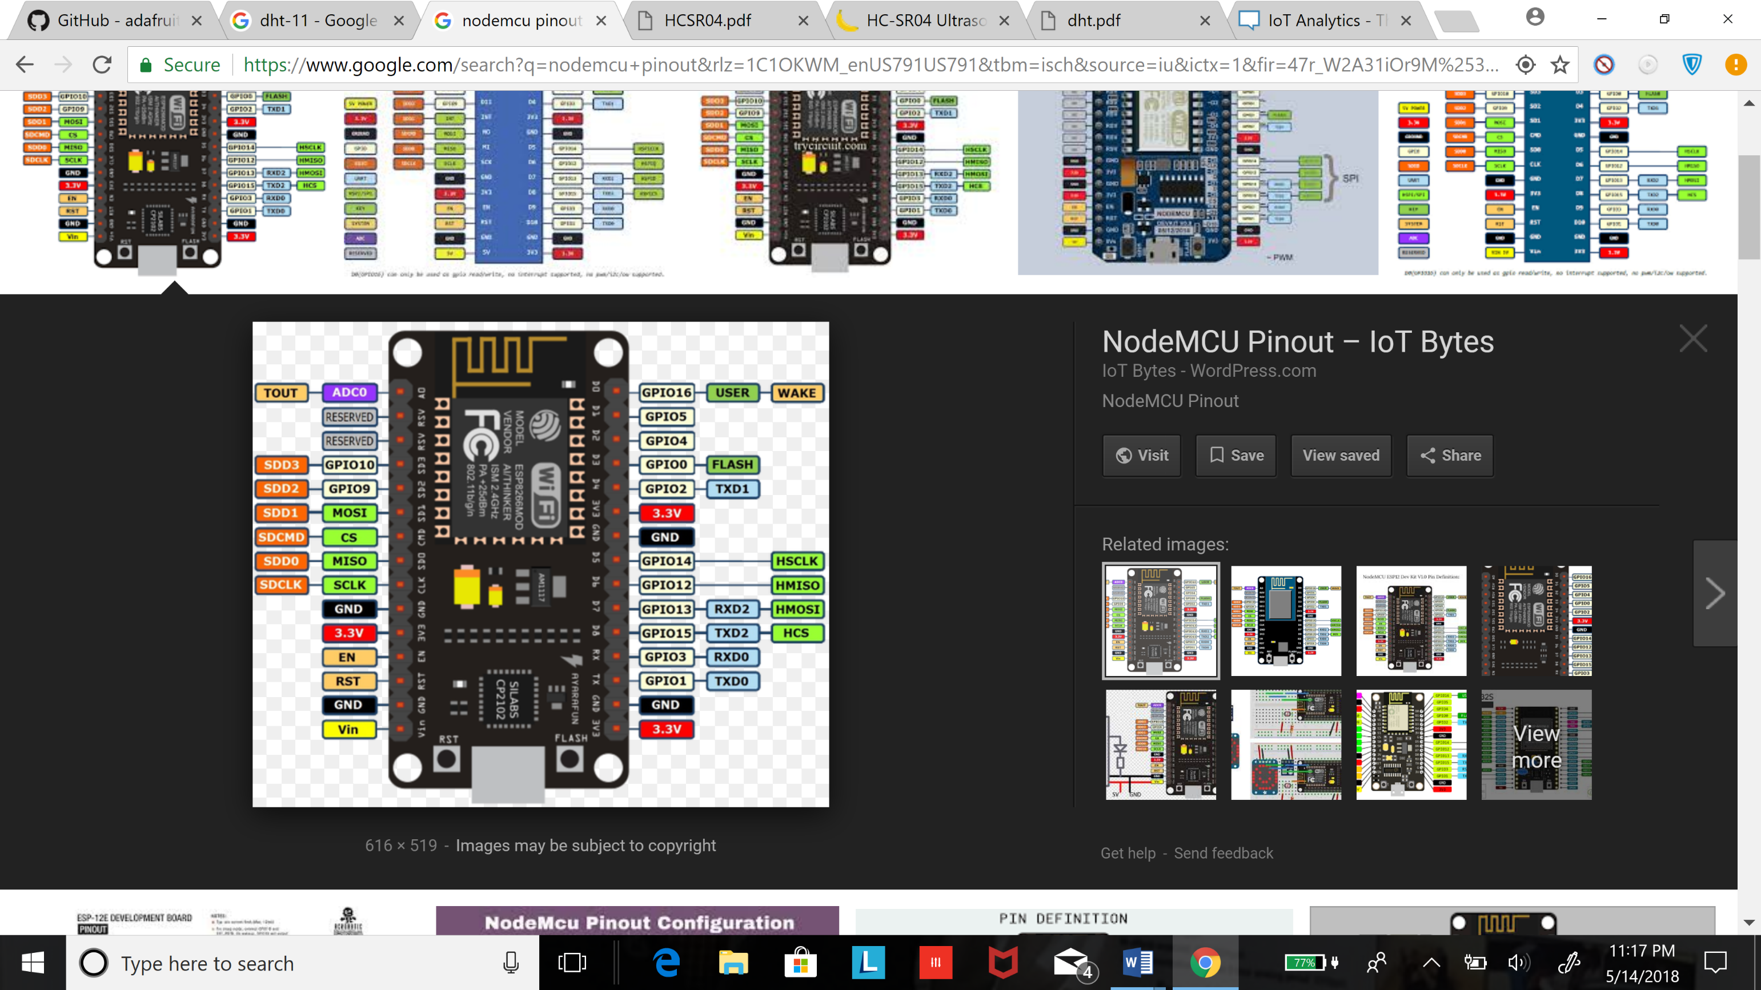

* Pinout of ESP8266

STEP 5:-

* Install DHT-11 library
* GO TO SKETCH < include library < manage library < try DHT download all library

|  |
| --- |
| **Code**  //soumil shah  [//soushah@my.bridgeport.edu](mailto://soushah@my.bridgeport.edu)  //Master in Electrical Enginner  //Master in computer Engineering  //Graduate Assistant  // GO TO SKETCH < include library < manage library < try DHT download all library  #include <DHT.h> // Including library for dht  #include <ESP8266WiFi.h> //we are using Node mcu  String apiKey = "Your API of thingsspeak"; // Enter your Write API key from ThingSpeak  const char *ssid = "Your wifi Network name"; // replace with your wifi ssid and wpa2 key  const char *pass = "Network password";  const char* server = "api.thingspeak.com";  #define DHTPIN 5 //pin where the dht11 is connected  DHT dht(DHTPIN, DHT11);  WiFiClient client;  void setup()  {  Serial.begin(115200);  delay(10);  dht.begin();  Serial.println("Connecting to ");  Serial.println(ssid);  WiFi.begin(ssid, pass);  while (WiFi.status() != WL_CONNECTED)  {  delay(500);  Serial.print(".");  }  Serial.println("");  Serial.println("WiFi connected");  }  void loop()  {  float h = dht.readHumidity(); // read humidity  float t = dht.readTemperature(); // read Temperature  if (isnan(h) || isnan(t))  {  Serial.println("Failed to read from DHT sensor!");  return;  }  if (client.connect(server,80)) // "184.106.153.149" or api.thingspeak.com  {  String postStr = apiKey;  postStr +="&field1=";  postStr += String(t); // upload temperature which was in variable t  postStr +="&field2=";  postStr += String(h); // upload humidity which was in variable h  postStr += “\r\n\r\n”;  client.print(“POST /update HTTP/1.1\n”);  client.print(“Host: api.thingspeak.com\n”);  client.print(“Connection: close\n”);  client.print(“X-THINGSPEAKAPIKEY: “+apiKey+”\n”);  client.print(“Content-Type: application/x-www-form-urlencoded\n”);  client.print(“Content-Length: “);  client.print(postStr.length());  client.print(“\n\n”);  client.print(postStr);  Serial.print(“Temperature: “);  Serial.print(t);  Serial.print(“ degrees Celcius, Humidity: “);  Serial.print(h);  Serial.println(“%. Send to Thingspeak.”);  }  client.stop();  Serial.println(“Waiting...”);  // thingspeak needs minimum 15 sec delay between updates, I’ve set it to 30 seconds  delay(10000);  } |

* The main key idea was to store data of sensor in variable t and h
* **postStr +="&field1="; this is Field which we choose which we early configured in cloud server**
* **postStr += String(t); We are posting string to cloud server**

**Try uploading Number from 1 to 100 to cloud server also with temperature and humidity Modify the Above code**

**Hint: - Copy paste the code make a variable temp store 0 in temp upload it and increment it**